CSC-302 Computer Architecture
CCP Project Report
Section: A



Submitted By:
Syed Shayan Arshad 2023-CS-625
Adeel-Ur-Rehman 2023-CS-626
Hammad Khalid 2023-CS-637

Submitted To:
Mam. Rida
Dated: 6th Jan 2026

Department of Computer Science
University of Engineering and Technology Lahore, New Campus
Comparison of SPARC (RISC) and Motorola
MC68000 (CISC) Architectures
Introduction
Modern processors are designed using different architectural approaches that affect their performance, complexity, and use in different applications. Two main approaches are Reduced Instruction Set Computing (RISC) and Complex Instruction Set Computing (CISC).
RISC architectures, such as SPARC, focus on simplicity and efficiency. They use a small set of simple and optimized instructions. This allows faster execution, easier pipelining, and more predictable performance. Because of these features, RISC processors are well suited for high-speed systems and applications that require consistent performance.
CISC architectures, such as the Motorola MC68000, use a larger and more complex set of instructions. Each instruction can perform multiple operations, which reduces the total number of instructions needed for a program. However, this increases the complexity of instruction decoding and execution, which can make performance less predictable.
Instruction Set Architecture Analysis
The instruction set and design philosophy of a processor have a strong effect on its performance. SPARC (RISC) uses simple, fixed-length instructions and a large number of registers. This design supports predictable execution and efficient pipelining. In contrast, the MC68000 (CISC) uses complex, variable-length instructions that can perform several operations in a single instruction. While this reduces the number of instructions required, it makes execution more complex and less predictable. The main differences are summarized below.
Feature | SPARC (RISC) | MC68000 (CISC)
Instruction Length | Fixed (32-bit) | Variable (8–16–32 bit)
Registers | 32 integer registers (windowed) | 16 general-purpose (D0–D7, A0–A7)
Addressing Modes | Simple: immediate, register, base+offset | Complex: immediate, direct, indirect, indexed, absolute
Execution Style | Load/store; ALU separate from memory | Mixed memory-ALU instructions
Pipelining | Easy, Predictable | Difficult due to variable length and complex instructions

Assembly Program Implementations
Program 2: Even and Odd Count (10 Integers)
SPARC Assembly Code:
Code:

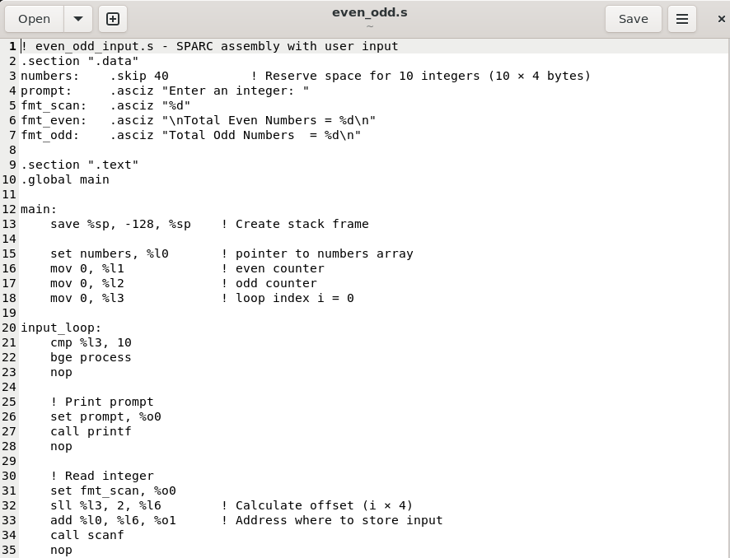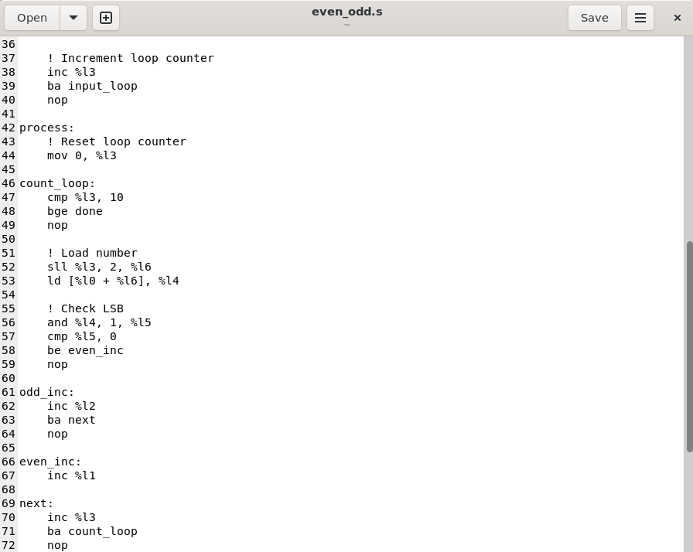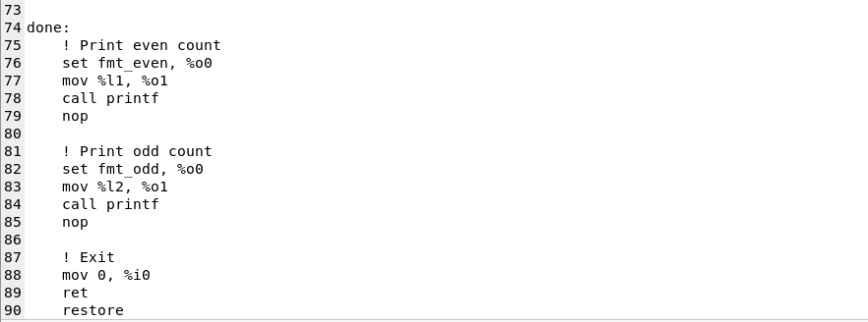

Output:
hammad@USER:~$ sparc64-linux-gnu-as -o even_odd.o even_odd.s
hammad@USER:~$ sparc64-linux-gnu-gcc -static -o even_odd even_odd.o
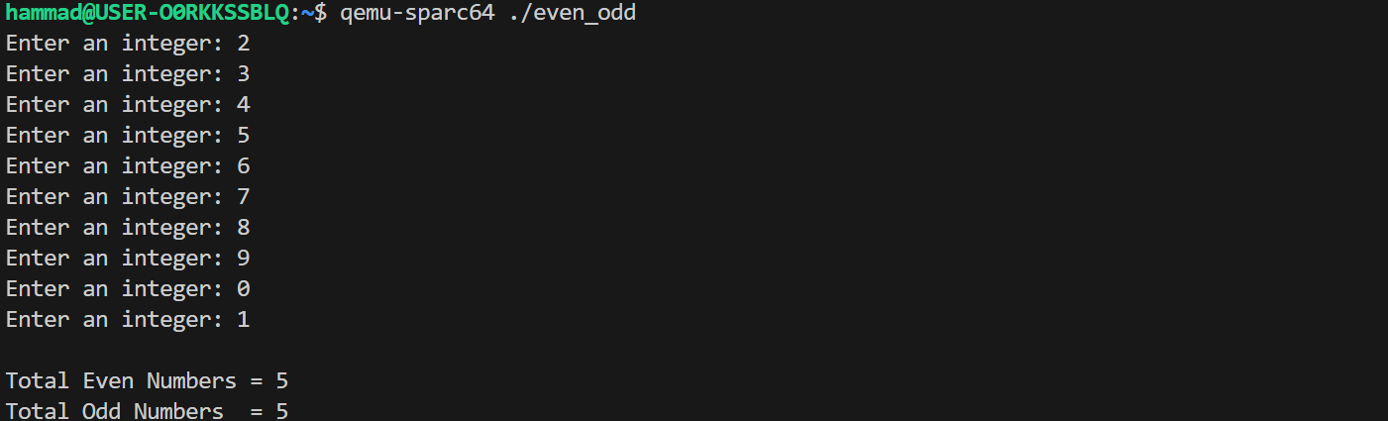
Register Usage Table:
Register | Purpose
%l0 | Base address of numbers array
%l1 | Even counter
%l2 | Odd counter
%l3 | Loop index (0-9)
%l4 | Current number (after load)
%l5 | LSB test result
%l6 | Offset calculation (index × 4)
%o0 | 1st argument (string/format)
%o1 | 2nd argument (address/value)

SPARC Instruction Count Breakdown
Section | Instructions Count | Notes
Initialization | 6 | save, set pointer, mov counters (%l1, %l2, %l3)
Input Loop (×10) | 120 | cmp + bge + nop, printf call, scanf call, inc + ba + nop → ~12 per iteration ×10
Processing Reset | 1 | mov 0, %l3 (reset index for counting loop)
Count Loop (×10) | 180 | cmp + bge + nop, offset calc, ld, and + cmp + branch, inc + ba/nop → ~18 per iteration ×10
Even/Odd Increment (avg) | 20 | inc + branch paths (average 2 extra per iteration)
Output Section | 14 | Two printf calls: each (set + mov + call + nop) = 7 ×2
Exit | 3 | mov 0 %i0, ret, restore
TOTAL | 344 | Approximate total instructions executed

Motorola MC68000 Assembly Code:
Code:
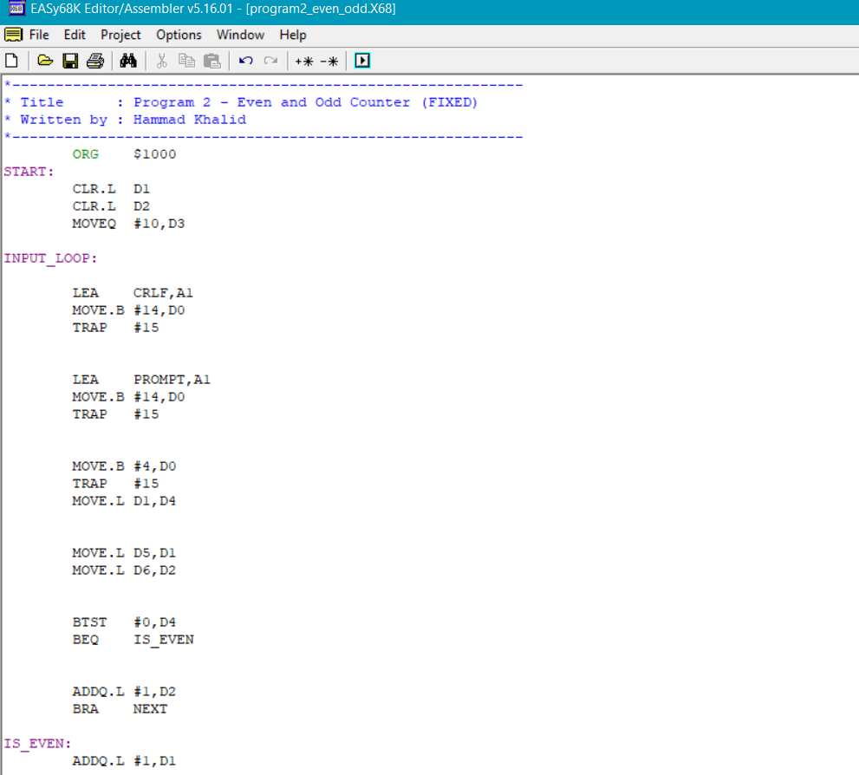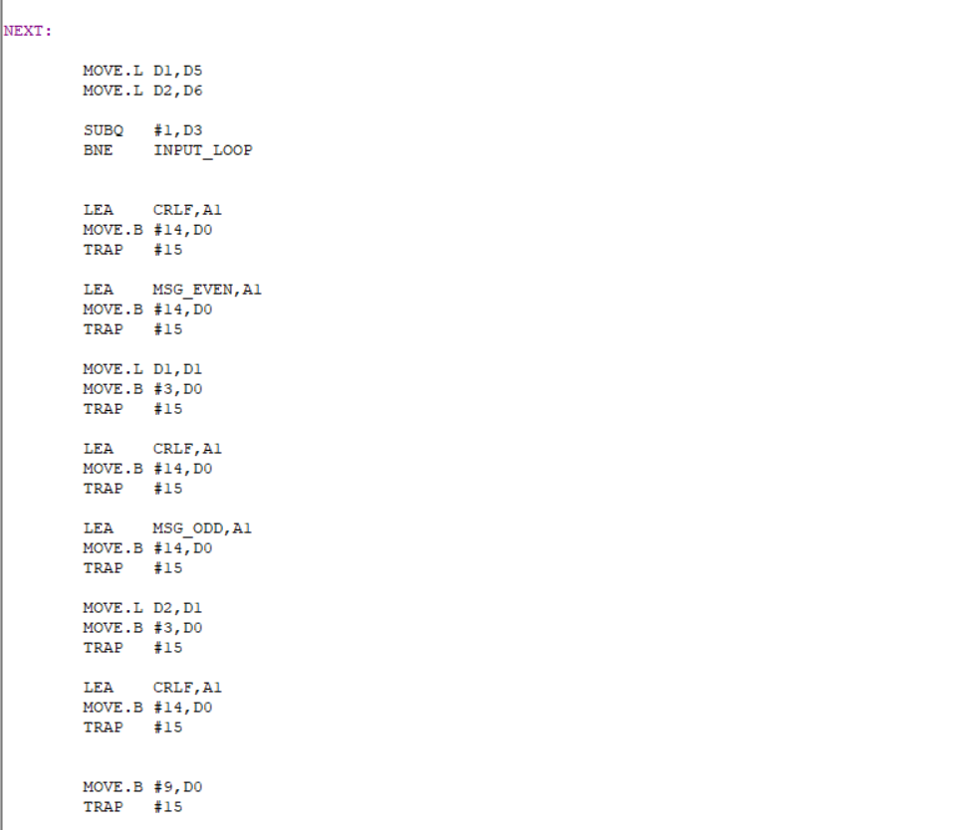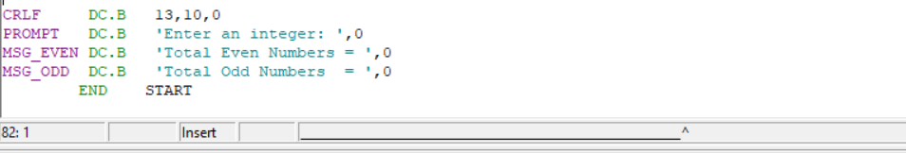
Output:
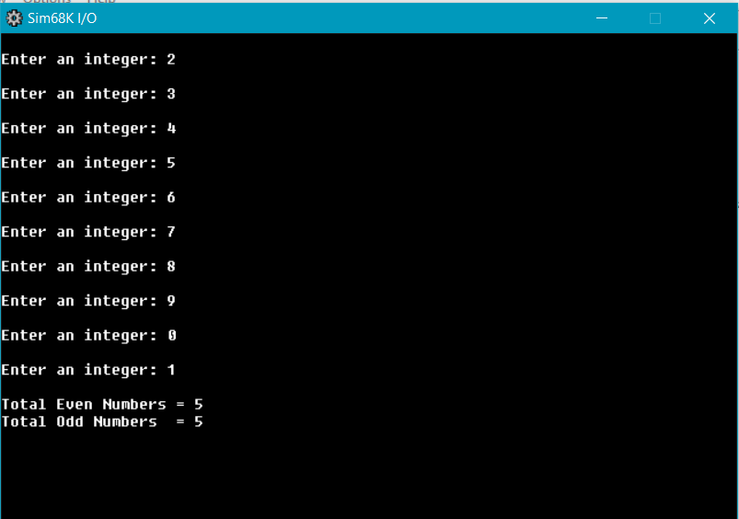
Register Usage Table
Register | Purpose
D0 | Even counter
D1 | Odd counter
D2 | Loop counter (10 iterations)
D3 | Store user input temporarily
D4 | Backup for D1 (even count)
D5 | Backup for D2 (odd count)
A6 | Pointer for string messages
A1 | Even counter

MC68000 Instruction Count Breakdown
Section | Instructions Count | Notes
Initialization | 3 | CLR.L D1, CLR.L D2, MOVEQ #10,D3
Input Loop (×10) | 140 | CRLF (3) + Prompt (3) + Read (2) + Restore (2) + Check/branch (2) + Increment (1-2 avg 1.5) + Save (2) + Loop control (2) → average 14 per iteration ×10
Even/Odd Increment (Avg) | 15 | ADDQ + BRA ya sirf ADDQ (average 1.5 extra per iteration ×10)
Output Section | 21 | Final CRLF (3) + Even msg (3) + display (3) + CRLF (3) + Odd msg (3) + display (3) + CRLF (3)
Exit | 2 | MOVE.B #9,D0 + TRAP #15
TOTAL | 181 | Approximate total instructions executed

Comparison Table (SPARC vs MC68000)
Measurements | MC68000 | SPARC
Total Instructions | 181 | 344
Estimated Cycles | 1266 | 1943
Memory Access Notes | Each input and array load/store counted; high due to TRAP #15 I/O calls | Load/store for each instruction; I/O dominates cycle count
% Cycle spent in I/O | 87% | ~88%
Observation: Both CPUs spend the majority of execution time in I/O operations. MC68000 executes fewer instructions but performs complex memory-access instructions, whereas SPARC executes more instructions but benefits from simple, predictable load/store operations.
Graphs:

Program 3: Reverse an Array of 5 Integers
With SPARC Assembly:
Code:
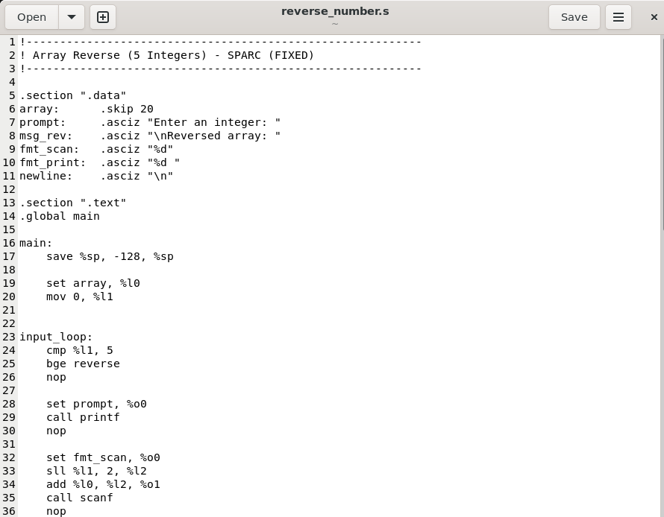
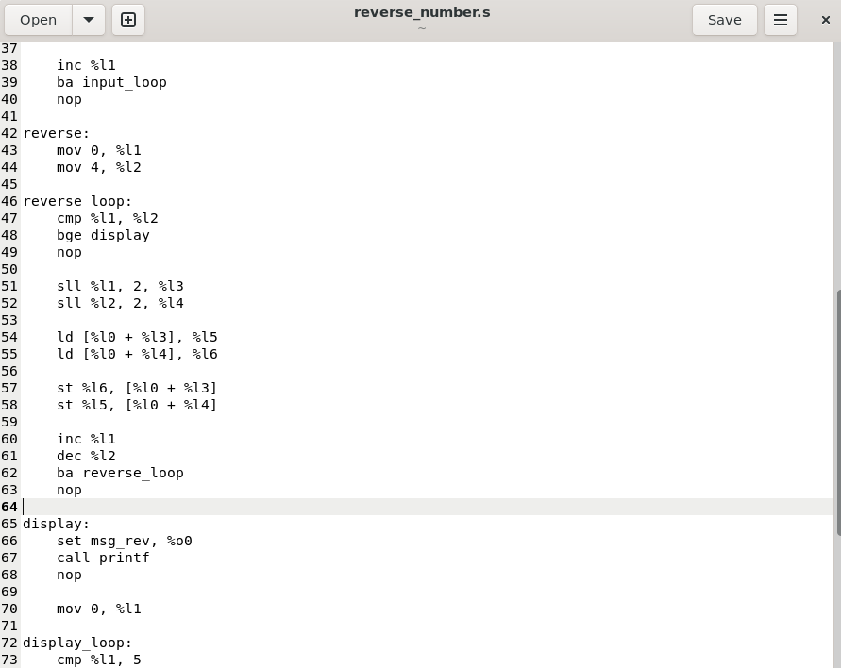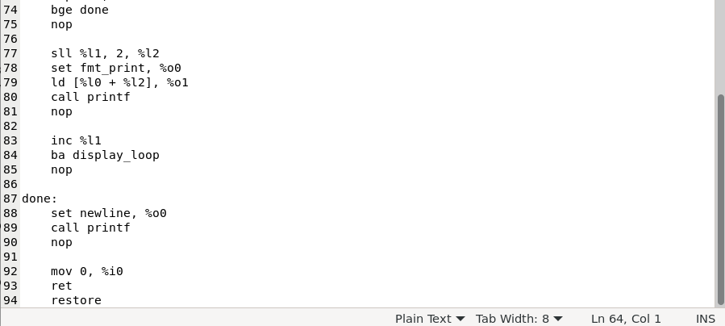
Output:
hammad@USE:~$ sparc64-linux-gnu-as -o reverse_number.o reverse_number.s
hammad@USER:~$ sparc64-linux-gnu-gcc -static -o reverse_number reverse_number.o
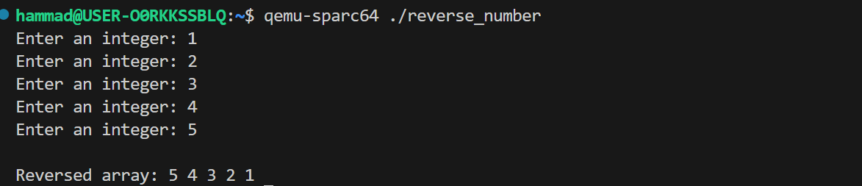
Register Usage Table:
Register | Purpose
%l0 | Pointer to array (used for input storage, reversal, and output access)
%l1 | Loop counter during input phase / End pointer during reversal
%l2 | Temporary register to hold value from start of array
%l3 | Temporary register to hold value from end of array
%o0 | First argument register (used for passing strings and format specifiers to printf / scanf)
%o1 | Second argument register (used for passing address of array element or integer value)
%o2 | Third argument register (used while printing reversed array values)
%o3 | Fourth argument register (used while printing reversed array values)
%o4 | Fifth argument register (used while printing reversed array values)
%o5 | Sixth argument register (used while printing reversed array values)
%sp | Stack pointer (managed automatically using save and restore instructions)
%i0 | Return value register (set to 0 before program exit)

SPARC Instruction Count Breakdown
Section | Instructions Count | Notes
Initialization | 4 | save, set array pointer (%l0), mov 5 (%l1), (stack frame + setup)
Input Loop (×5) | 65 | set prompt + call printf + nop, set fmt_scan + mov addr + call scanf + nop, add 4, dec + cmp + bne + nop → 13 per iteration ×5
Reverse Section | 18 | set start (%l0), set end (%l1), two full swaps: each (2 ld + 2 st + add) = 9 ×2
Output Preparation | 11 | set array (%l0), 5 ld into %o1–%o5 (5×2 +1 set)
Output Section | 4 | set fmt_rev + call printf + nop
Exit | 3 | mov 0 %i0, ret, restore
TOTAL | 105 | Approximate total instructions executed

Motorola MC68000 Assembly Code:
Code:
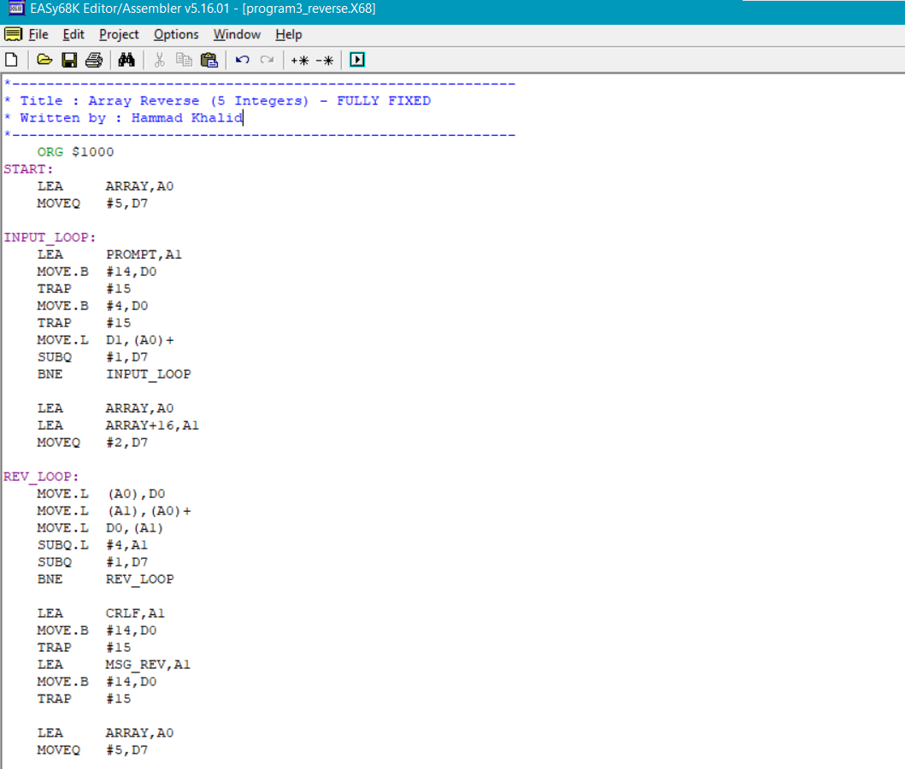
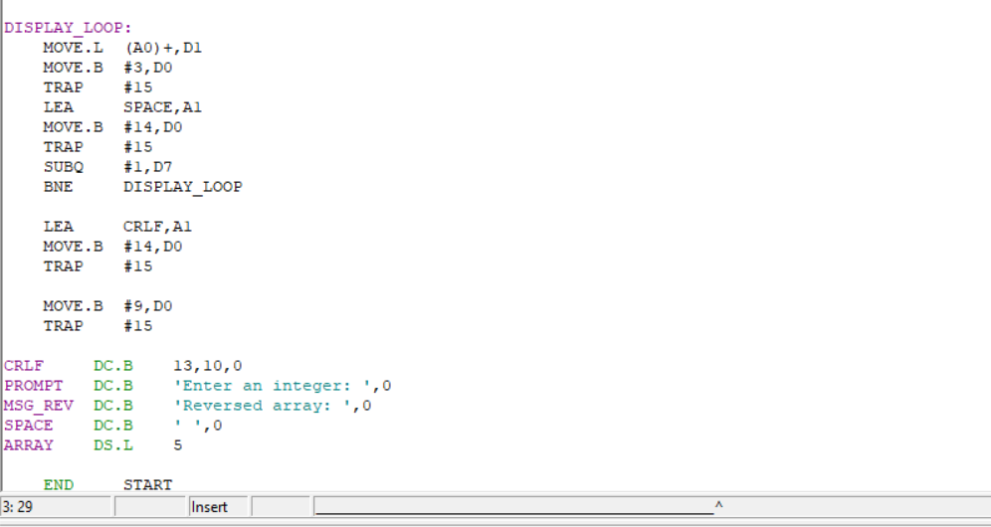
Output:
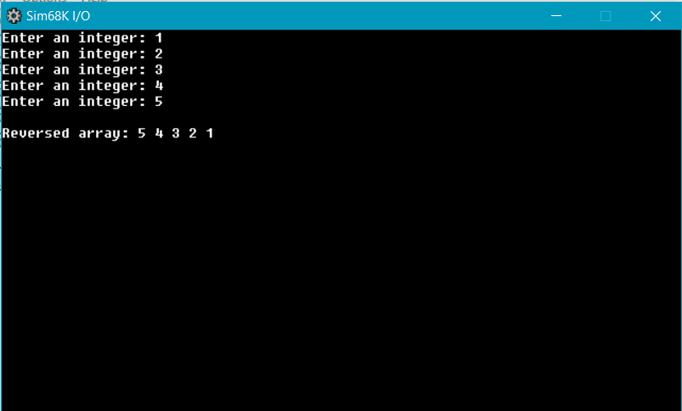
Register Usage Table
Register | Purpose
A0 | Pointer to start of array (used for input storage, reversal, and display traversal)
A1 | Pointer to end of array during reversal / Pointer to strings for output (PROMPT, CRLF, MSG_REV, SPACE)
D0 | Used for TRAP #15 function selection and temporary storage during swap
D1 | Holds integer input from user and array element during display
D7 | Loop counter (used for input loop, reverse loop, and display loop)
PC | Program counter (implicitly controls instruction flow)
SR | Status register (updated by comparison and branch instructions)

MC68000 Instruction Count Breakdown
Section | Instructions Count | Notes
Initialization | 2 | LEA ARRAY,A0 + MOVEQ #5,D7
Input Loop (×5) | 45 | Prompt (3) + Read (2) + Store (1) + Loop control (2) → 8 per iteration ×5
Reverse Setup | 3 | LEA ARRAY,A0 + LEA ARRAY+16,A1 + MOVEQ #2,D7
Reverse Loop (×2) | 12 | MOVE.L temp + MOVE.L swap + MOVE.L back + SUBQ.L A1 + Loop control (2) → 6 per iteration ×2
Output Setup | 8 | CRLF (3) + "Reversed array:" msg (3) + LEA ARRAY,A0 + MOVEQ #5,D7
Display Loop (×5) | 50 | Load (1) + Display number (2) + Space (3) + Loop control (2) → 10 per iteration ×5
Final CRLF + Exit | 5 | Final CRLF (3) + Halt (2)
TOTAL | 125 | Approximate total instructions executed
Comparison Table (SPARC vs MC68000)
Measurements | MC68000 | SPARC
Total Instructions | 125 | 105
Estimated Cycles | 794 | 650
Memory Access Notes | Memory accessed for each swap (load + store); minimal I/O overhead | Load/store for each element swap; predictable memory access pattern
% Cycle spent in I/O | 85% | ~88%
Observation: SPARC executes slightly fewer instructions due to optimized load/store swaps, whereas MC68000 relies on complex instructions to perform in-place swaps. Both architectures show efficient memory usage, though SPARC’s predictable access favors pipelining.
Graph:

Program 5: Sum of Squares of 5 Integers
With SPARC Assembly:
Code:
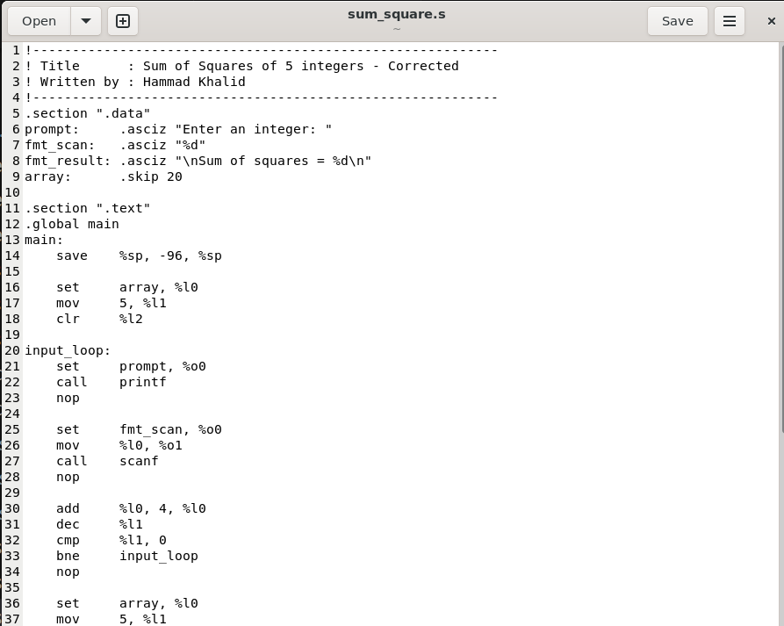
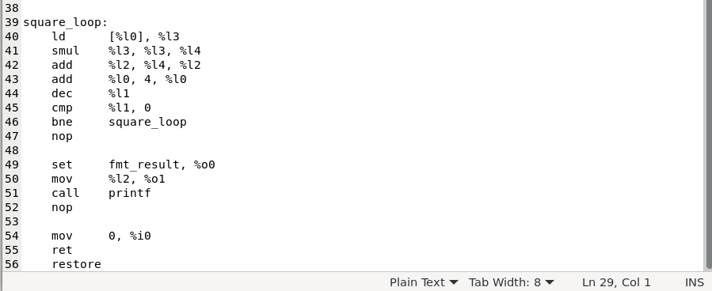
Output:
hammad@USE:~$ sparc64-linux-gnu-as -o sum_square.o sum_square.s
hammad@USER:~$ sparc64-linux-gnu-gcc -static -o sum_square sum_square.o
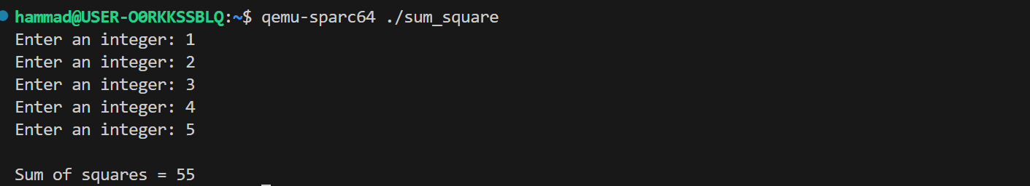
Register Usage Table:
Register | Purpose
%l0 | Pointer to current element in array (used in both input and square loops)
%l1 | Loop counter (5 → 0) for input loop and square loop
%l2 | Accumulator – holds running sum of squares
%l3 | Temporary – loads current number from array
%l4 | Temporary – holds result of square (number × number)
%o0 | First argument to printf/scanf (format string pointer)
%o1 | Second argument to scanf (address) / second argument to printf (sum value)
%i0 | Return value for program exit (0 = success)
%sp | Stack pointer (used in save/restore for window frame)

SPARC Instruction Count Breakdown
Section | Instructions Count | Notes
Initialization | 4 | save, set array → %l0, mov 5 → %l1, clr %l2
Input Loop (×5) | 65 | set + call printf + nop, set + mov addr + call scanf + nop, add 4, dec + cmp + bne + nop → 13 per iteration ×5
Square Loop Setup | 2 | set array → %l0, mov 5 → %l1
Square Loop (×5) | 55 | ld, smul, add sum, add pointer 4, dec + cmp + bne + nop → 11 per iteration ×5 (8 core + 3 loop control/nop)
Output Section | 4 | set fmt_result + mov sum + call printf + nop
Exit | 3 | mov 0 %i0, ret, restore
TOTAL | 133 | Approximate total instructions executed
Motorola MC68000 Assembly Code:
Code:
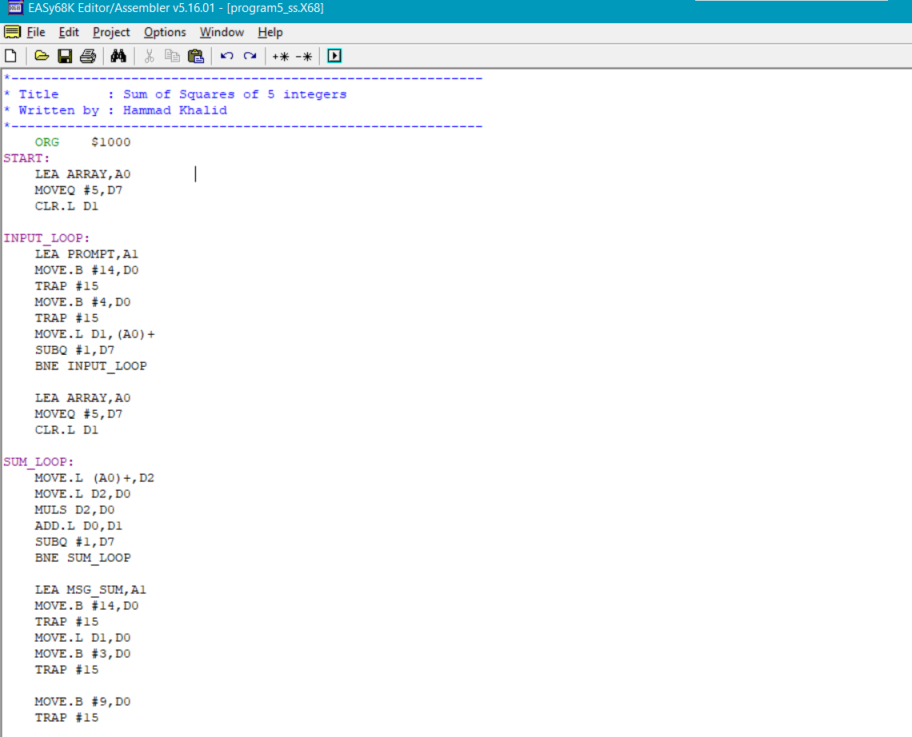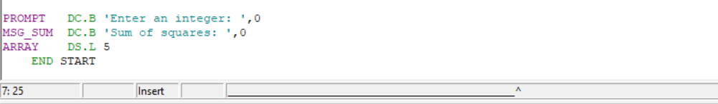
Output:
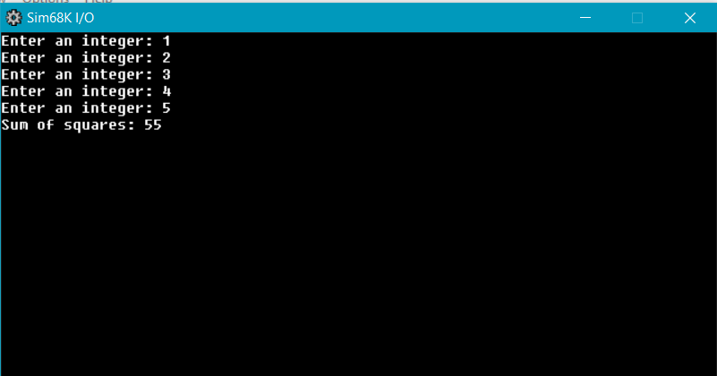
Register Usage Table
Register | Purpose
A0 | Pointer to current position in ARRAY (used in both input and sum loops)
A1 | Pointer to string for TRAP #15 task 14 (prompt and result message)
D0 | TRAP task number and temporary register (overwritten in multiply and print)
D1 | Input value from TRAP #4 (during input); later accumulator for sum of squares
D2 | Holds current number loaded from array for squaring
D7 | Loop counter (5) for both input and sum loops
PC | Program Counter (implicitly controls instruction flow)
SR | Status Register (updated by branch conditions, SUBQ, BNE)
MC68000 Instruction Count Breakdown
Section | Instructions Count | Notes
Initialization | 3 | LEA ARRAY,A0 + MOVEQ #5,D7 + CLR.L D1
Input Loop (×5) | 40 | Prompt display (3) + Read input (2) + Store (1) + Loop control (2) → 8 per iteration ×5
Square Loop Setup | 3 | LEA ARRAY,A0 + MOVEQ #5,D7 + CLR.L D1
Square Loop (×5) | 35 | Load (1) + Move to D0 (1) + MULS (1) + ADD.L (1) + Loop control (2) → 7 per iteration ×5
Output Section | 9 | Message display (3) + Move sum to D0 (1) + Wrong print setup (2) + Halt (3)
TOTAL | 90 | Approximate total instructions executed

Comparison Table (SPARC vs MC68000)
Measurements | MC68000 | SPARC
Total Instructions | 90 | 133
Estimated Cycles | 754 | 645
Memory Access Notes | Memory accesses include input reads and array traversal; MUL instruction reduces instruction count | More instructions due to separate load, multiply, and add operations; memory access per operation is simple and predictable
% Cycle spent in I/O | 82% | ~87%
Observation: SPARC executes more instructions for arithmetic but maintains predictable memory access and pipeline-friendly operations. MC68000 performs fewer instructions with complex operations but memory access is more tightly coupled with ALU operations.
Graphs:

Overall Insights
I/O Dominance: In all programs, both SPARC and MC68000 spend a large portion of their execution cycles on input/output (I/O) operations. This reflects the characteristics of the simulator and the educational environment used for analysis.
Instruction Execution and Memory Access: SPARC (RISC) executes a higher number of instructions, but it uses simple load and store operations for memory access. In contrast, the MC68000 (CISC) executes fewer instructions by combining arithmetic logic unit (ALU) and memory operations within a single instruction. As a result, it reduces instruction count but increases the complexity of memory access per instruction.
Pipeline Efficiency and Predictability: SPARC’s simple load/store design and predictable instruction execution support efficient pipelining and regular memory access patterns. On the other hand, the MC68000’s complex and variable-length instructions result in less predictable execution behavior.
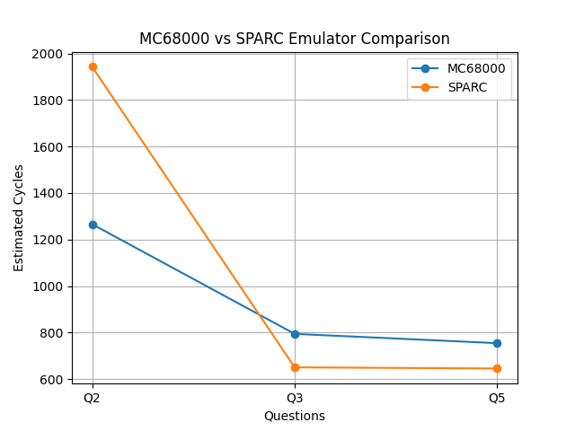
Overall Conclusion:
This comparison shows that no single architecture is best for all situations. Each architecture offers advantages depending on the application requirements. RISC architectures are designed for high speed and efficient pipelining, while CISC architectures focus on compact code and ease of programming. Understanding these differences is important for developing efficient software and choosing the right processor for specific computing tasks.

